**Artificial Intelligence One Year Project**

**Assignment - 08**

**Classification Assignment**

**1.) Identify Your Problem Statement: -**

* **Classification**

**2.) Tell Basic Info About The Dataset (Total Number Of Rows, Columns)**

* **399 rows, 25 columns**

**3.) Mention The Pre-Processing Method If You’re Doing Any (Like Converting String To Number – Nominal Data)**

* **get dummies (.get_dummies)**

**4.) Develop A Good Model With Good Evaluation Metric. You Can Use Any Machine Learning Algorithm; You Can Create Many Models. Finally, You Have To Come Up With Final Model.**

* **Finaly, I choose this model RF-Grid-Classification gave the best performance**

1. **Logistic-Grid-Classification report:**

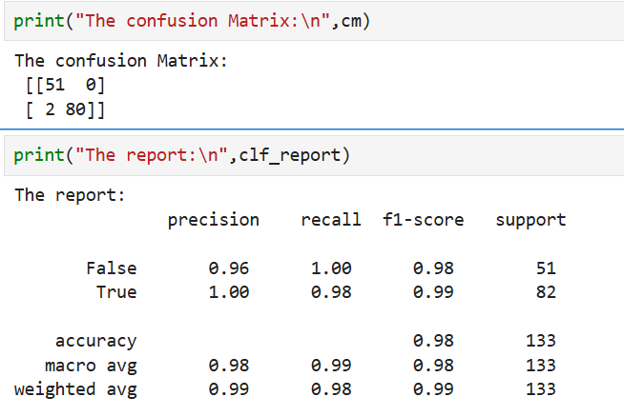

1. **DC-Grid report:**

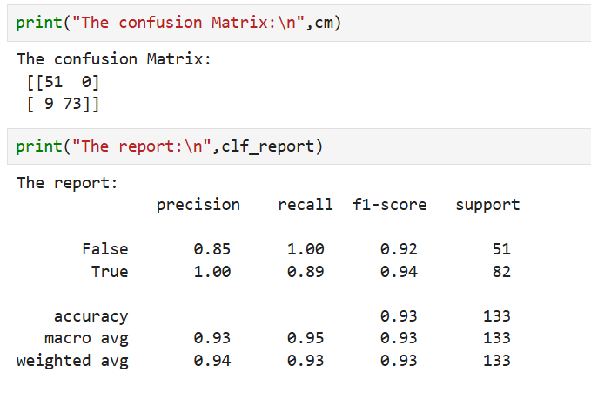

1. **KNN report:**

1. **RF-Grid-Classification report:**

1. **SVM-Grid-Classification report:**

1. **Naive Bayes – BernoulliNB report:**

1. **Naive bayes ComplementNB report:**

1. **Naive bayes MaltinomialNB report:**

1. **Naive bayes GaussianNB report:**

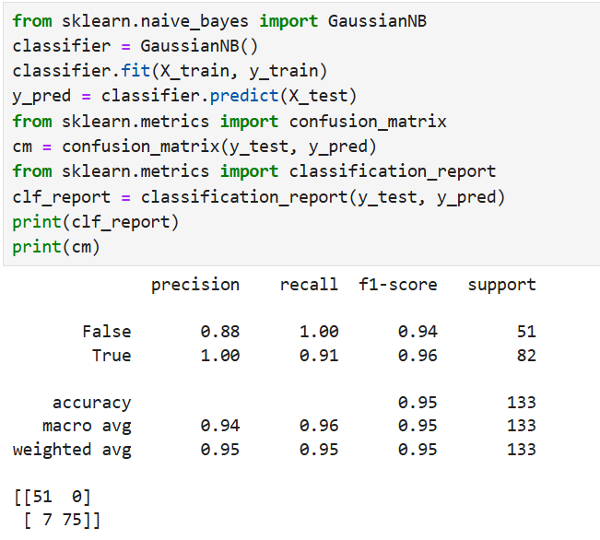

**5.) All The Research Values Of Each Algorithm Should Be Documented. (You Can Make Tabulation Or Screenshot Of The Results.)**

**6.) Mention Your Final Model, Justify Why U Have Chosen The Same.**

* **RF-Grid-Classification Gave The Best Performance, F1 Score And Accuracy =0.99; The Model Also Produced Good Results On The Test Data. That’s Why I Selected RF-Grid-Classification As The Final Model.**